Overview
The program I am working on is to help the Hom biology lab to discover interesting interactions with micro organisms. We want to see what organism could make a community a live harmoniously together. This program is to help supplement research and provide stronger evidence to claims made in lab experiments. I chose this project because I wanted to do something completely new and exciting. This project is something I look forward to seeing the end result myself.

MVP
The MVP is a desktop application the simulates micro-organisms using agent-based algorithms to mimic how real-world chemistry and biology function. The purpose is to run the environments and collect statistical data about different variables in the experiment.

User Interface/ Users
There is really only one user “class” for this project. The users will be biology scientists with an interest in micro-organisms environments. The main interactions the user will be exposed to is inputting and saving details of chemical compounds, micro-organisms, and simulation settings. As well as the ability to run experiments based on those inputs, and afterwards, receiving statistical data for them to reflect and use in further research.
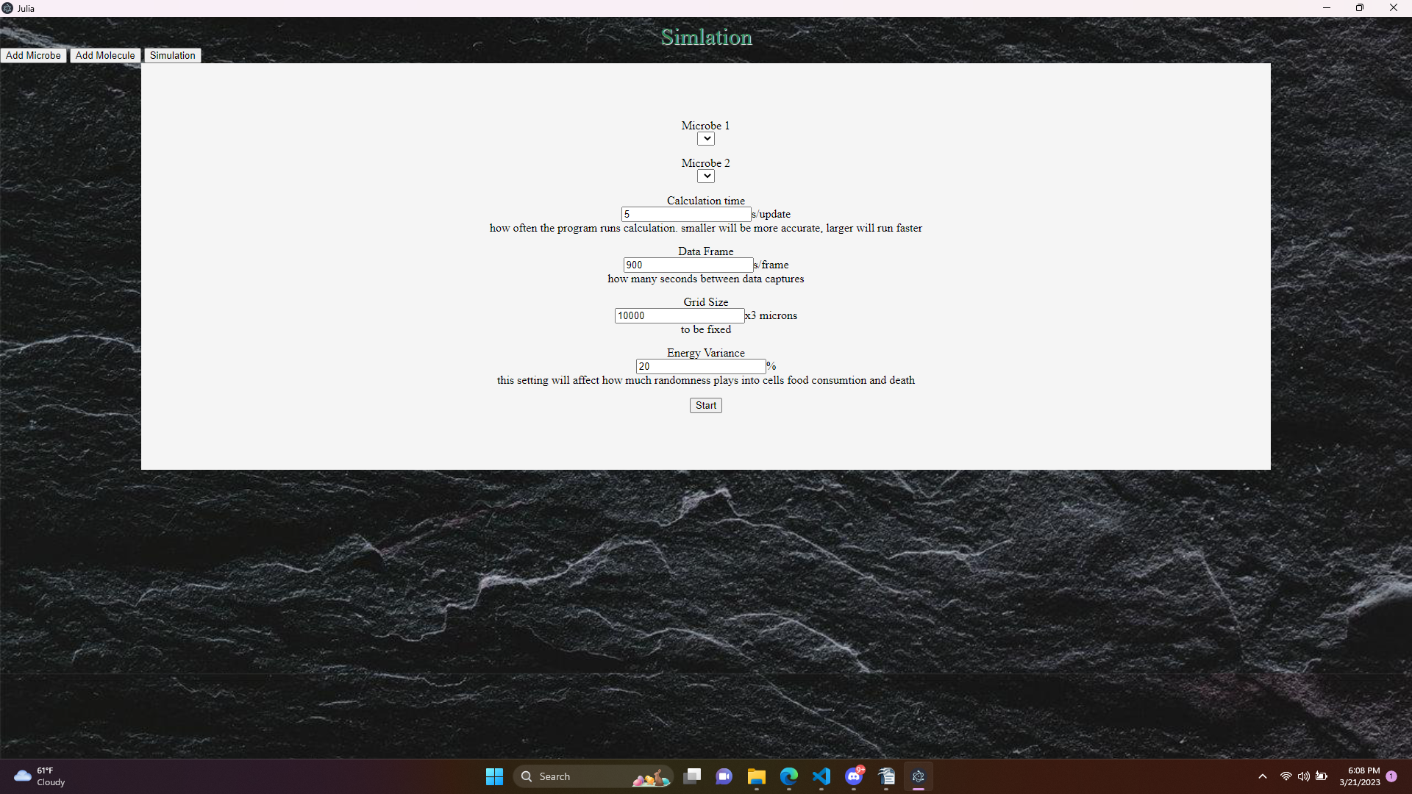
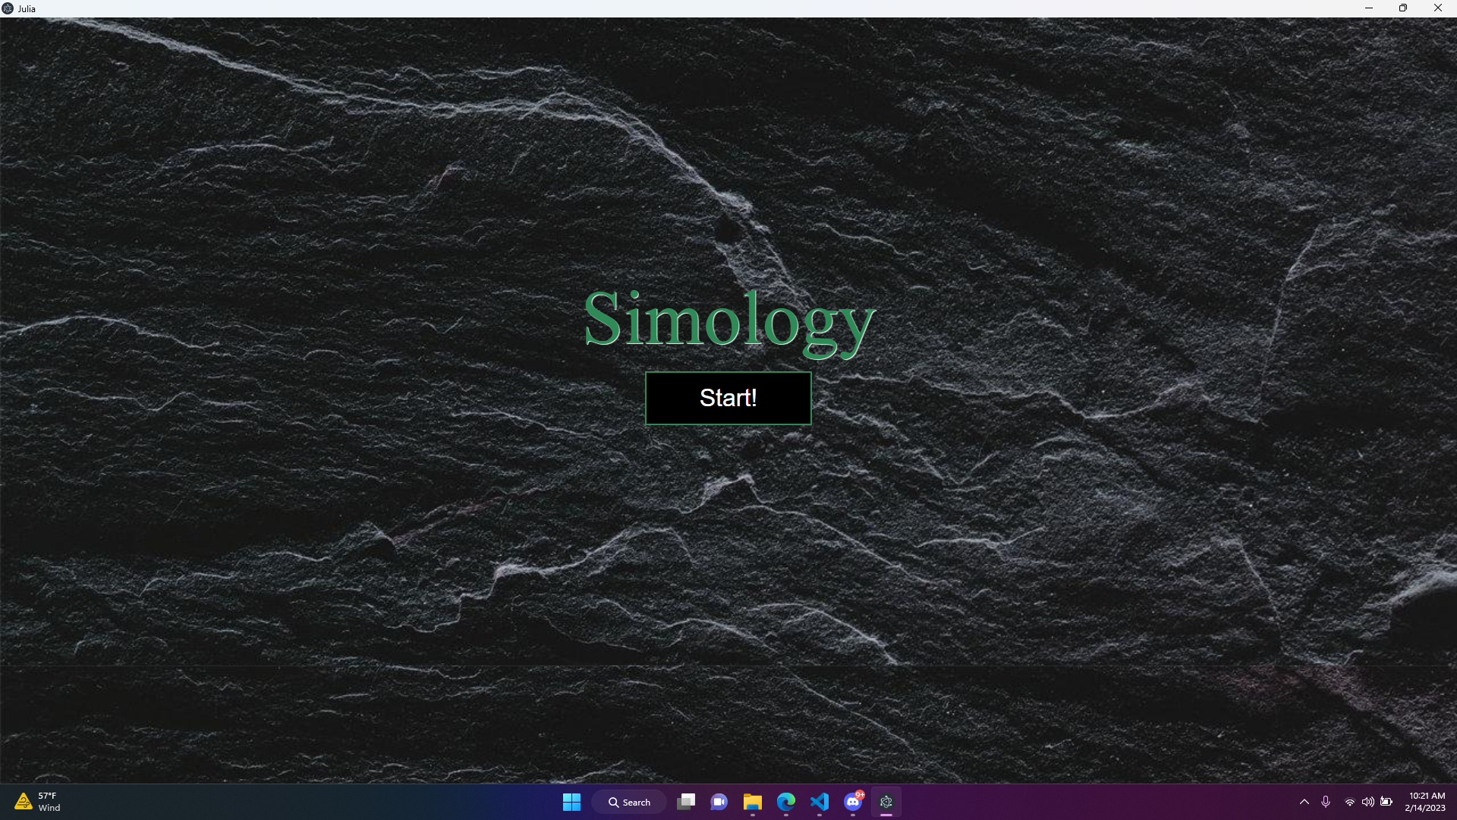
**i currently don't have an output screen developed

Design Options
I will be using Julia for the bulk of the program. This was requested by the client after some research I found that it was capable of doing what was needed for the project. Julia is my back-end with Blink, which is built from electron, to handle window creation and message passing from front to back. The front and UI is build using HTML, CSS, and Javascript. This is the only front-end technology that I am familiar with. The hardest part of this stack is the use of Julia. It is a completely new language to me and I will have to learn as I go. The estimate of API usage is about 15% only being used for middle of the stack.
Another stack I thought about using was the unreal Engine. Usually used for video games but could work for a program like this. Again its entirely new to me and would have to learn the entire stack that is built into the engine. Which would take a lot of time but ultimately I think it would run better. As unreal engine has been out much longer and has had time work clean up bugs and coding issues. This stack is much more reliant on code packages at about 50%.

Design Choice
Ultimately, I chose to go with the first option. Julia is a language made for scientific calculations and is incredibly fast. This project contains a lot of math and matrix manipulation. Also as I learn Julia, the easier and faster I find to code in. The language syntax is simple and concise. The biggest factor however is it was the requested language to use by my mentor. The Stack overall is powerful and is built with science in mind.

Development
I am using a windows pc with Intel i-7 processor with 16gb of ram. I am using Microsoft Visual Studio Code as my IDE of choice. I have installed Julia and the VS code extension. I have linked it with my Github at https://github.com/T1M3L05T/Senior-project .

Deployment
This project will be deployed directly to the users machine. The system will require at least 8gb of RAM and dual-core processor. Julia will need to be installed, and a package file will need to be ran prior to using the program. Finally it will require about 1 GB of HDD space (not including Julia packages).

Testing Plan
Julia has built-in unit testing and I will be utilizing it to test all back-end functions. As for javascript and front-end, most testing will be done visually and from the perspective of the user. Final test will be comparing simulation results to real-world experiments to verify accuracy.

Timeline
- 3/27 finish and run my first simulation
- 3/27 create tests
- 3/27 Debug/ check with department to make sure its life-like
- 4/3 format and design output
- 4/10 polish and change with the direction of sponsor
Bibliography
- https://docs.julialang.org/en/v1/
- Professor Erik Hom from UM interviews
- https://www.researchgate.net/publication/235619517_From_Cytoplasm_to_Environment_The_Inorganic_Ingredients_for_the_Origin_of_Life

